***Assignment 7 – Arrays***

*Arjun Patel - FRN-13J1124/006*

Q1) Find minimum and maximum number in array.

*#include*<stdio.h>

int main(){

    int n;

    printf("Enter the size of array\n");

    scanf("%d", *&*n);

    int arr[n];

*for* (int i *=* 0; i *<* n; i*++*)

    {

        printf("Enter the value at index %d: ", i);

        scanf("%d", *&*arr[i]);

    }

    int max *=* arr[0], min *=* arr[0];

*for* (int i *=* 0; i *<* n; i*++*)

    {

        printf("Value at index %d: %d\n", i, arr[i]);

*if*(arr[i]*<*min){

            min *=* arr[i];

        }

*if*(arr[i]*>*max){

            max *=* arr[i];

        }

    }

    printf("\nLargest number in array is %d\n", max);

    printf("Smallest number in array is %d\n", min);

*return* 0;

}

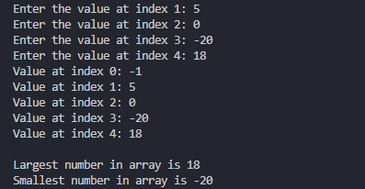

Q2) Search the given number in array.

*#include*<stdio.h>

int main(){

    int n;

    printf("Enter the size of an array:\n");

    scanf("%d", *&*n);

    int arr[n];

*for* (int i *=* 0; i *<* n; i*++*)

    {

        printf("Enter the value at index %d: ", i);

        scanf("%d", *&*arr[i]);

    }

    int searchNum, flag*=* 1;

    printf("Enter a number u want to search in array\n");

    scanf("%d", *&*searchNum);

*for* (int i *=* 0; i *<* n; i*++*)

    {

*if*(arr[i]*==*searchNum){

            printf("%d is on index: %d\n", searchNum, i);

            flag *=* 0;

*break*;

        }

    }

*if* (flag)

    {

        printf("%d is not available in array\n", searchNum);

    }

*return* 0;

}

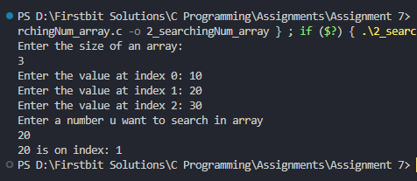

Q3) Find sum of all numbers.

*#include*<stdio.h>

int main(){

     int n;

    printf("Enter the size of an array:\n");

    scanf("%d", *&*n);

    int arr[n], sum *=* 0;

*for* (int i *=* 0; i *<* n; i*++*)

    {

        printf("Enter the value at index %d: ", i);

        scanf("%d", *&*arr[i]);

        sum *+=* arr[i];

    }

    printf("Sum of all number of array is %d", sum);

*return* 0;

}

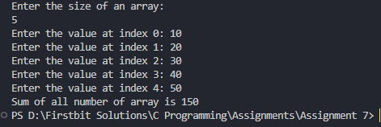

Q4) Find odd and even among the numbers.

*#include*<stdio.h>

int main(){

    int n;

    printf("Enter the size of an array:\n");

    scanf("%d", *&*n);

    int arr[n], sum *=* 0;

*for* (int i *=* 0; i *<* n; i*++*)

    {

        printf("Enter the value at index %d: ", i);

        scanf("%d", *&*arr[i]);

    }

*//print even number*

    printf("--------Even Nums in Array-------\n");

*for* (int i *=* 0; i *<* n; i*++*)

    {

*!*(arr[i]*%*2) *&&* printf("%d ", arr[i]);

    }

*//print odd number*

    printf("\n--------Odd Nums in Array-------\n");

*for* (int i *=* 0; i *<* n; i*++*)

    {

        arr[i]*%*2 *&&* printf("%d ", arr[i]);

    }

*return* 0;

}

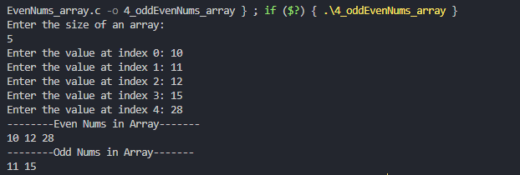

Q5) Print alternate elements in array.

*#include*<stdio.h>

int main(){

    int n;

    printf("Enter the size of an array:\n");

    scanf("%d", *&*n);

    int arr[n], sum *=* 0;

*for* (int i *=* 0; i *<* n; i*++*)

    {

        printf("Enter the value at index %d: ", i);

        scanf("%d", *&*arr[i]);

    }

*for* (int i *=* 0; i *<* n; i*=*i*+*2)

    {

        printf("%d ", arr[i]);

    }

*return* 0;

}

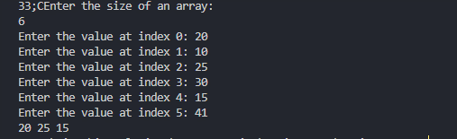

Q6) Accept array and print only prime numbers of array.

*#include*<stdio.h>

void checkPrime(int arr[], int n){

*for* (int i *=* 0; i *<* n; i*++*)

    {

*if*(arr[i]*==*1) *continue*;

        int isPrime *=* 1;

*for* (int j *=* 2; j*\**j *<=* arr[i]; j*++*)

        {

*if*(arr[i] *%* j *==* 0){

                isPrime *=* 0;

*break*;

            }

        }

*if* (isPrime)

        {

            printf("%d ", arr[i]);

        }

    }

}

int main(){

    int n;

    printf("Enter the size of an array:\n");

    scanf("%d", *&*n);

    int arr[n], sum *=* 0;

*for* (int i *=* 0; i *<* n; i*++*)

    {

        printf("Enter the value at index %d: ", i);

        scanf("%d", *&*arr[i]);

    }

    checkPrime(arr,n);

*return* 0;

}

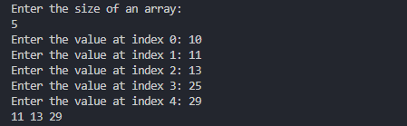

Q7) Take two array and add sum in third array

Example-

arr[5]= {1,2, 3, 4,5}

brr[5]={10,20,30, 40, 50}

crr[5]={11,22,33,44,55}

*#include*<stdio.h>

int main(){

    int n;

    printf("Enter the size of an array:\n");

    scanf("%d", *&*n);

    int arr[n], sum *=* 0;

*//taking arr 1 from user*

    printf("------Array 1 - arr --------\n");

*for* (int i *=* 0; i *<* n; i*++*)

    {

        printf("Enter the value at index %d: ", i);

        scanf("%d", *&*arr[i]);

    }

    int brr[n], crr[n];

*//taking brr (2) from user*

    printf("------Array 1 - arr --------\n");

*for* (int i *=* 0; i *<* n; i*++*)

    {

        printf("Enter the value at index %d: ", i);

        scanf("%d", *&*brr[i]);

    }

*//find sum and adding in crr in respective element*

*for* (int i *=* 0; i *<* n; i*++*)

    {

        crr[i] *=* arr[i] *+* brr[i];

        printf("crr[%d] = %d\n",i, crr[i]);

    }

*return* 0;

}

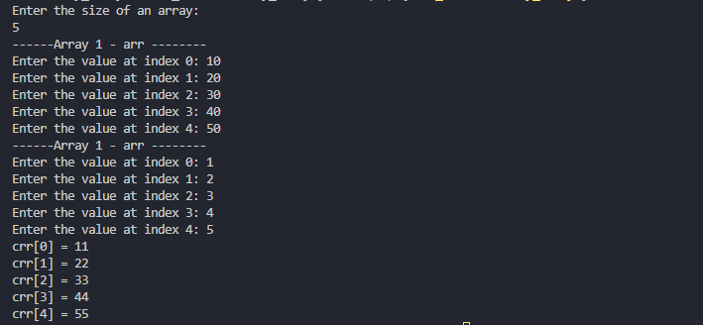

Q8)Merge Two arrays

*#include*<stdio.h>

int main(){

    int n;

    printf("Enter the size of an array:\n");

    scanf("%d", *&*n);

    int arr1[n], arr2[n];

*//taking arr 1 from user*

    printf("-----Enter values for Array 1-----\n");

*for* (int i *=* 0; i *<* n; i*++*)

    {

        printf("Enter the value at index %d: ", i);

        scanf("%d", *&*arr1[i]);

    }

*//taking arr 2 from user*

    printf("-----Enter values for Array 2-----\n");

*for* (int i *=* 0; i *<* n; i*++*)

    {

        printf("Enter the value at index %d: ", i);

        scanf("%d", *&*arr2[i]);

    }

    int arr3[2*\**n];

*//adding values from arr1 to arr3*

*for* (int i *=* 0; i *<* n; i*++*)

    {

        arr3[i] *=* arr1[i];

    }

*//adding values from arr2 to arr3*

*for* (int i *=* n; i *<* 2*\**n; i*++*)

    {

        arr3[i] *=* arr2[i*-*n]; *//i=4, arr[]*

    }

*//printing arr3*

*for* (int i *=* 0; i *<* 2*\**n; i*++*)

    {

        printf("%d ", arr3[i]);

    }

*return* 0;

}

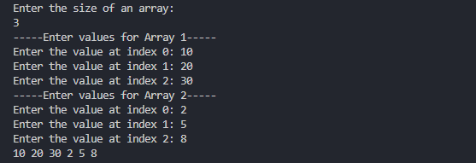

Q9)Reverse given array

*#include*<stdio.h>

void reverseArray(int arr[], int n){

*for* (int i *=* 0; i *<=* n*/*2; i*++*)

    {

        int temp *=* arr[i]; *//1 2*

        arr[i] *=* arr[n*-*i*-*1]; *//a[0] = a[3-0-1] = a[2] = 3 2*

        arr[n*-*i*-*1] *=* temp; *// a[2] = temp = 1 2*

*// printf("%d ", arr[i]);*

    }

*//printng reversed array*

*for* (int i *=* 0; i *<* n; i*++*)

    {

        printf("%d ", arr[i]);

    }

}

int main(){

    int n;

    printf("Enter the size of an array:\n");

    scanf("%d", *&*n);

    int arr[n];

*//taking arr from user*

    printf("-----Enter values for Array 1-----\n");

*for* (int i *=* 0; i *<* n; i*++*)

    {

        printf("Enter the value at index %d: ", i);

        scanf("%d", *&*arr[i]);

    }

*//reverse array*

    reverseArray(arr,n);

*return* 0;

}

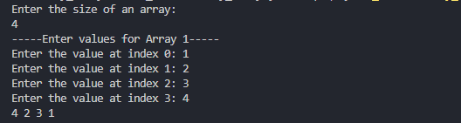

Q10) Sort the array.

*#include*<stdio.h>

int main(){

    int n;

    printf("Enter the size of an array:\n");

    scanf("%d", *&*n);

    int arr[n];

*//taking arr from user*

*for* (int i *=* 0; i *<* n; i*++*)

    {

        printf("Enter the value at index %d: ", i);

        scanf("%d", *&*arr[i]);

    }

*for* (int i *=* 0; i *<* n; i*++*)

    {

*for* (int j *=* i*+*1; j *<* n; j*++*)

        {

*if*(arr[i]*>*arr[j]){

                int temp *=* arr[i];

                arr[i] *=* arr[j];

                arr[j] *=* temp;

            }

        }

    }

*//printing array*

*for* (int i *=* 0; i *<* n; i*++*)

    {

        printf("%d ", arr[i]);

    }

*return* 0;

}

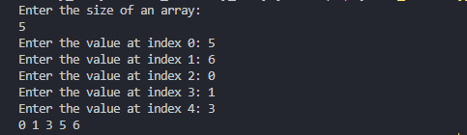

***-------END-------***